Notice of Instruction  5911 Breckenridge Parkway, Suite F  Tampa, Florida 33610  (813) 740-3888 | 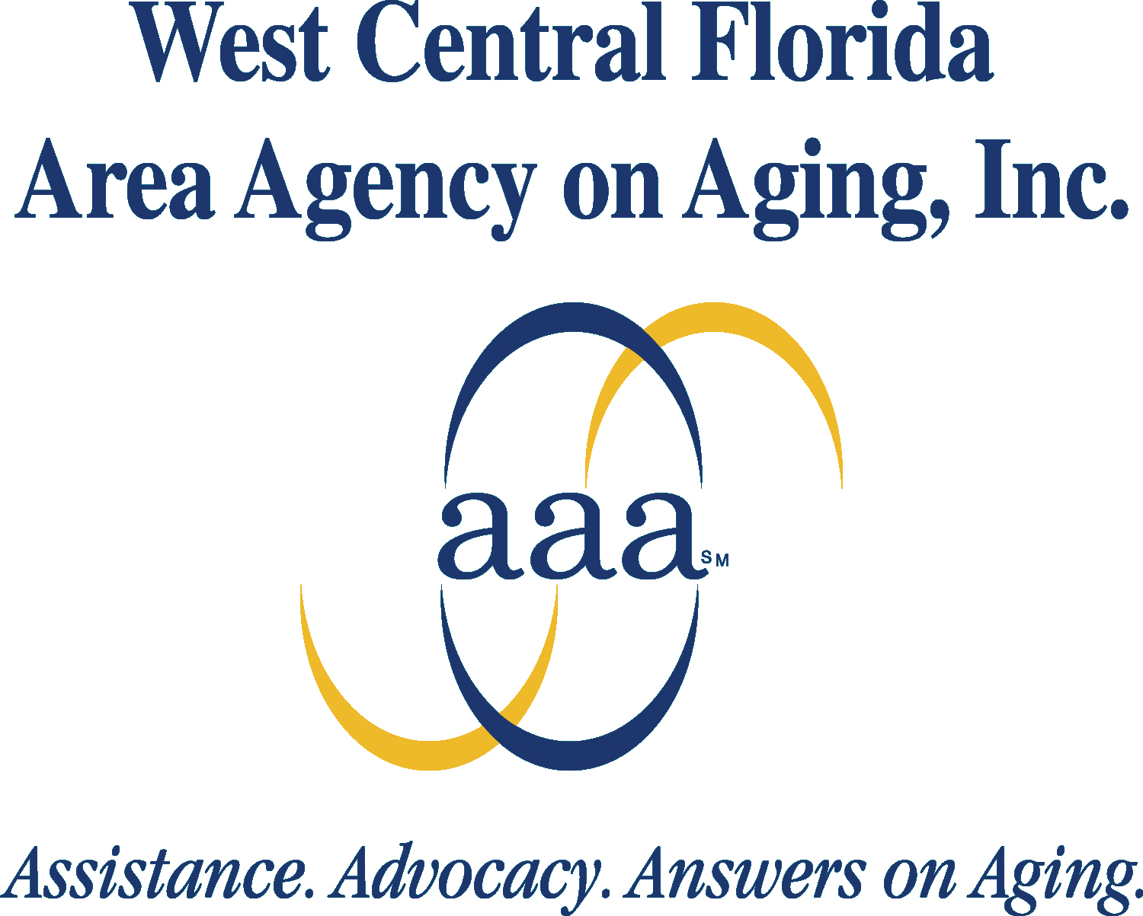

Notice of Instruction Number: #052511 – Updated Co-Pay Information - kp

TO: All Lead Agencies

FROM: Katie Parkinson, Director of Program Management

DATE: July 28, 2026

SUBJECT: 2011 Co-Pay Information Update

The purpose of this Notice of Instruction is to provide WCFAAA’s Lead Agencies with the updated information for determining the 2011 co-pay assessment for clients receiving Community Care for the Elderly (CCE) and Alzheimer’s Disease Initiative (ADI) services. The source for the co-pay criteria is the SSI-Related Programs Financial Eligibility Standards: April 2011, posted on the Department of Children and Families’ web site at: http://www.dcf.state.fl.us/programs/access/docs/ssi_fin_elig_chart.pdf

The following attachments are included with this notice:

- 2011 Community Care for the Elderly (CCE) and Alzheimer’s Disease Initiative (ADI) co-pay schedules for individuals and couples (Attachment A).

- Co-pay financial worksheet and assessed co-pay form (Attachment B).

- Financial worksheet instructions (Attachment C).

- SSI-Related Programs Fact Sheets, April 2011.

It is necessary that this information is immediately sent to your staff to ensure implementation and compliance with the use of the updated co-pay documents.

WCFAAA appreciates your prompt attention and cooperation in regards to this directive. Thank you for your continued commitment to Florida’s elders. Should you require additional program information, please contact your WCFAAA Program Manager.

Attachments

